Problem_Set_3

Amy Richardson

3/16/2021

#Initiate packages

library(ggplot2)  
library(tidyr)  
library (dplyr)

library(granova)

library(car)  
library(Rcmdr)

library(pastecs)

library(compute.es)  
library(WRS2)  
library(gmodels)

Read in Data

sat_df <- read.csv("SAT.csv", header = TRUE)

Change Character columns (Race.Ethnicity and Sex) to factors.

sat_df <- sat_df %>% mutate(Sex_factor = as.factor(Sex))  
sat_df <- sat_df %>% mutate(Race_factor = as.factor(Race.Ethnicity))  
sat_df <- sat_df %>% mutate(MATH = as.numeric(MATH))

## Part 1

### There is no difference between scores on the English section of the SAT among racial/ethnic groups.

Plot histograms of English Scores among racial/ethnic groups

sat_df %>%  
 ggplot(aes(x = ERW, fill = Race_factor)) +  
 geom_histogram () +  
 facet_grid(Race_factor ~., scales = "free")

## `stat_bin()` using `bins = 30`. Pick better value with `binwidth`.

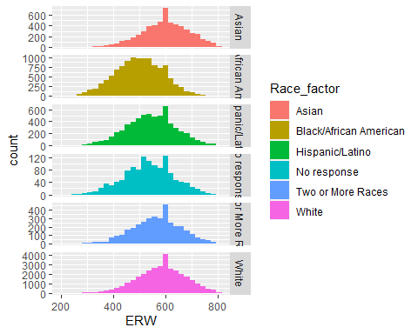

Run descriptive statistics for each group

by(sat_df$ERW, sat_df$Race_factor, stat.desc)

## sat_df$Race_factor: Asian  
## nbr.val nbr.null nbr.na min max range   
## 5.541000e+03 0.000000e+00 0.000000e+00 2.700000e+02 8.000000e+02 5.300000e+02   
## sum median mean SE.mean CI.mean.0.95 var   
## 3.318810e+06 6.000000e+02 5.989551e+02 1.205387e+00 2.363031e+00 8.050839e+03   
## std.dev coef.var   
## 8.972647e+01 1.498050e-01   
## ------------------------------------------------------------   
## sat_df$Race_factor: Black/African American  
## nbr.val nbr.null nbr.na min max range   
## 1.169900e+04 0.000000e+00 0.000000e+00 2.000000e+02 8.000000e+02 6.000000e+02   
## sum median mean SE.mean CI.mean.0.95 var   
## 5.848080e+06 5.000000e+02 4.998786e+02 8.602215e-01 1.686178e+00 8.657038e+03   
## std.dev coef.var   
## 9.304320e+01 1.861316e-01   
## ------------------------------------------------------------   
## sat_df$Race_factor: Hispanic/Latino  
## nbr.val nbr.null nbr.na min max range   
## 6.157000e+03 0.000000e+00 0.000000e+00 2.300000e+02 8.000000e+02 5.700000e+02   
## sum median mean SE.mean CI.mean.0.95 var   
## 3.356030e+06 5.400000e+02 5.450755e+02 1.185232e+00 2.323469e+00 8.649202e+03   
## std.dev coef.var   
## 9.300109e+01 1.706206e-01   
## ------------------------------------------------------------   
## sat_df$Race_factor: No response  
## nbr.val nbr.null nbr.na min max range   
## 1.231000e+03 0.000000e+00 0.000000e+00 2.400000e+02 7.800000e+02 5.400000e+02   
## sum median mean SE.mean CI.mean.0.95 var   
## 6.592800e+05 5.300000e+02 5.355646e+02 2.705593e+00 5.308087e+00 9.011205e+03   
## std.dev coef.var   
## 9.492737e+01 1.772473e-01   
## ------------------------------------------------------------   
## sat_df$Race_factor: Two or More Races  
## nbr.val nbr.null nbr.na min max range   
## 3.694000e+03 0.000000e+00 0.000000e+00 2.800000e+02 8.000000e+02 5.200000e+02   
## sum median mean SE.mean CI.mean.0.95 var   
## 2.093500e+06 5.700000e+02 5.667298e+02 1.520664e+00 2.981424e+00 8.542079e+03   
## std.dev coef.var   
## 9.242337e+01 1.630819e-01   
## ------------------------------------------------------------   
## sat_df$Race_factor: White  
## nbr.val nbr.null nbr.na min max range   
## 3.263500e+04 0.000000e+00 0.000000e+00 2.100000e+02 8.000000e+02 5.900000e+02   
## sum median mean SE.mean CI.mean.0.95 var   
## 1.910021e+07 5.900000e+02 5.852677e+02 5.062344e-01 9.922380e-01 8.363478e+03   
## std.dev coef.var   
## 9.145205e+01 1.562568e-01

### The data appears to be normally distributed. The makes sense as the data set is very large and standardized tests such as SAT are designed by normal distribution.

Plot boxplots of English Scores among Racial/ethnic groups

sat_df %>%   
 ggplot(aes(x = Race_factor, y = ERW)) +  
 geom_boxplot() +  
 labs(title = "Boxplot of English SAT scores by Race/Ethinicity",  
 x ="Race/Ethnicity",  
 y = "English SAT Scores") +  
 theme(plot.title = element_text(hjust = 0.5))

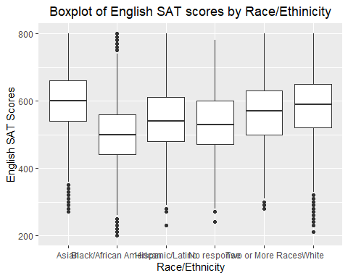

### There appears to be little variation between groups as the boxes and error bars overlap.

Levene’s Test - Assumption of Homogeneity of variance.

leveneTest(sat_df$ERW, sat_df$Race_factor, center = median)

## Levene's Test for Homogeneity of Variance (center = median)  
## Df F value Pr(>F)   
## group 5 2.2886 0.04329 *  
## 60951   
## ---  
## Signif. codes: 0 '***' 0.001 '**' 0.01 '*' 0.05 '.' 0.1 ' ' 1

### This output indicates that Levene’s test is significant, the variances are different accross groups. However, the sample size is quite large and in large samples even small differences in variances might be deemed significant. I will contintue with the one-way independent ANOVA test.

Run ANOVA

anova_model <- aov(ERW ~ Race_factor, data = sat_df)  
summary(anova_model)

## Df Sum Sq Mean Sq F value Pr(>F)   
## Race_factor 5 72860267 14572053 1726 <2e-16 ***  
## Residuals 60951 514679583 8444   
## ---  
## Signif. codes: 0 '***' 0.001 '**' 0.01 '*' 0.05 '.' 0.1 ' ' 1

Post-Hoc tests Will use Bonferrioni (samples sizes are not equal, going to control for Type I error)

pairwise.t.test(sat_df$ERW, sat_df$Race_factor, p.adjust.method = "bonferroni")

##   
## Pairwise comparisons using t tests with pooled SD   
##   
## data: sat_df$ERW and sat_df$Race_factor   
##   
## Asian Black/African American Hispanic/Latino  
## Black/African American <2e-16 - -   
## Hispanic/Latino <2e-16 <2e-16 -   
## No response <2e-16 <2e-16 0.014   
## Two or More Races <2e-16 <2e-16 <2e-16   
## White <2e-16 <2e-16 <2e-16   
## No response Two or More Races  
## Black/African American - -   
## Hispanic/Latino - -   
## No response - -   
## Two or More Races <2e-16 -   
## White <2e-16 <2e-16   
##   
## P value adjustment method: bonferroni

Effect Size using values from ANOVA results omega^2 = (SSM - df * MSR) / (SST + MSR) omega^2 = (72860267- 5*8444) / (72860267 + 514679583 + 8444) omega = 0.35

## Part 2

The mean of the scores in the sample for the English section on the SAT is 550. (meaning not significantly different from 550)

Run one sample t-test

num_3_ttest <- t.test(sat_df$ERW, mu = 550)  
num_3_ttest

##   
## One Sample t-test  
##   
## data: sat_df$ERW  
## t = 35.049, df = 60956, p-value < 2.2e-16  
## alternative hypothesis: true mean is not equal to 550  
## 95 percent confidence interval:  
## 563.1576 564.7164  
## sample estimates:  
## mean of x   
## 563.937

effect size

t<-num_3_ttest$statistic[[1]]  
df<-num_3_ttest$parameter[[1]]  
r <- sqrt(t^2/(t^2+df))  
round(r, 3)

## [1] 0.141

statistically the mean does not vary significantly from 550 however practically there is a small effect size (between 0.1 < r < 0.3)

Assumptions for t-test + Normality - descriptions and plots + Independent - assuming that no one took the test twice + Continuous - the English scores are continuous

Descriptive statistics

round(stat.desc(sat_df$ERW, basic = TRUE, norm = FALSE), digits = 3)

## nbr.val nbr.null nbr.na min max range   
## 60957.000 0.000 0.000 200.000 800.000 600.000   
## sum median mean SE.mean CI.mean.0.95 var   
## 34375910.000 570.000 563.937 0.398 0.779 9638.753   
## std.dev coef.var   
## 98.177 0.174

Histogram of English scores

hist_ENG_all <- ggplot(sat_df, aes (ERW))+ theme(legend.position = "none") +  
 geom_histogram(color = "black", fill = "white", binwidth = 10) +  
 labs(title = "Histogram of SAT English Scores", x = "English Scores", y = "Density")  
  
hist_ENG_all

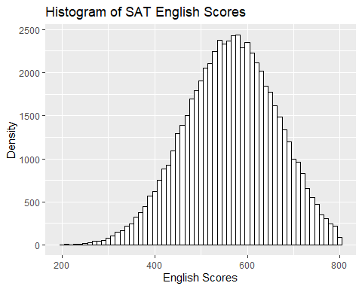

Q-Q Plot of Math scores

qqplot.satENG <- qplot(sample = sat_df$ERW, stat="qq")  
qqplot.satENG + labs(title = "QQPlot for SAT English Scores", x = "Thoeretical", y = "Sample")

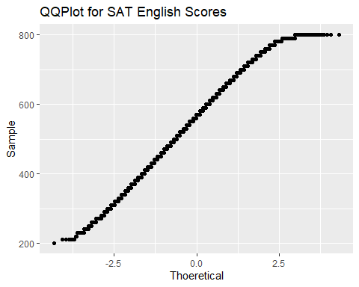

## Part 3

The observed distribution of values of the mathematics section is approximately normal.

Descriptive statistics

round(stat.desc(sat_df$MATH, basic = TRUE, norm = FALSE), digits = 3)

## nbr.val nbr.null nbr.na min max range   
## 60957.000 0.000 0.000 200.000 800.000 600.000   
## sum median mean SE.mean CI.mean.0.95 var   
## 33328170.000 550.000 546.749 0.443 0.869 11972.713   
## std.dev coef.var   
## 109.420 0.200

Histogram of Math scores

hist_satMath <- ggplot(sat_df, aes (MATH))+ theme(legend.position = "none") +  
 geom_histogram(color = "black", fill = "white", binwidth = 10) +  
 labs(title = "Histogram of SAT Math Scores", x = "Math Scores", y = "Density")  
  
hist_satMath

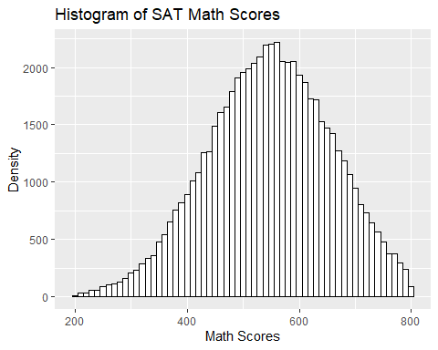

Q-Q Plot of Math scores

qqplot.satMATH <- qplot(sample = sat_df$MATH, stat="qq")  
qqplot.satMATH+ labs(title = "QQPlot for SAT Math Scores", x = "Thoeretical", y = "Sample")

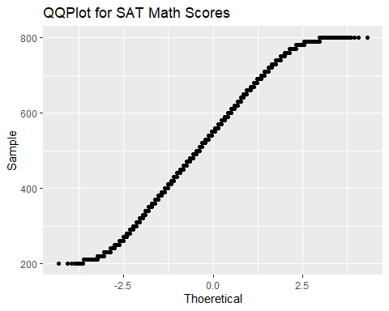

Cannot run Shapiro Wilk’s test since sample size is so big. Assume data is normally distributed.

## Part 4

There is no difference between male and female scores on the mathematics section of the SAT.

Create an errorbar plot

sat_df %>%   
 ggplot(aes(x = Sex_factor, y = MATH)) +   
 geom_boxplot() +  
 labs(title = "Boxplot of Math SAT scores by Gender",  
 x ="Gender",  
 y = "Math SAT Scores") +  
 theme(plot.title = element_text(hjust = 0.5))

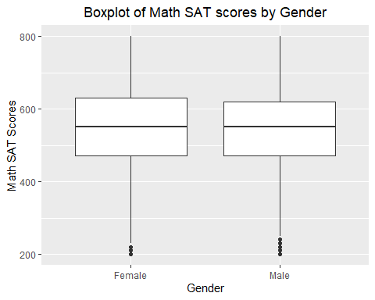 ### There appears to be little variation between groups as the boxes and error bars overlap.

General Statistics

by(sat_df$MATH, sat_df$Sex_factor, stat.desc, )

## sat_df$Sex_factor: Female  
## nbr.val nbr.null nbr.na min max range   
## 3.230700e+04 0.000000e+00 0.000000e+00 2.000000e+02 8.000000e+02 6.000000e+02   
## sum median mean SE.mean CI.mean.0.95 var   
## 1.766572e+07 5.500000e+02 5.468078e+02 6.101938e-01 1.196003e+00 1.202907e+04   
## std.dev coef.var   
## 1.096771e+02 2.005771e-01   
## ------------------------------------------------------------   
## sat_df$Sex_factor: Male  
## nbr.val nbr.null nbr.na min max range   
## 2.865000e+04 0.000000e+00 0.000000e+00 2.000000e+02 8.000000e+02 6.000000e+02   
## sum median mean SE.mean CI.mean.0.95 var   
## 1.566245e+07 5.500000e+02 5.466824e+02 6.447415e-01 1.263724e+00 1.190957e+04   
## std.dev coef.var   
## 1.091310e+02 1.996241e-01

Independent t-test for Math Scores comparing Genders

ind.t.test <- t.test(MATH ~ Sex_factor, data = sat_df)  
ind.t.test

##   
## Welch Two Sample t-test  
##   
## data: MATH by Sex_factor  
## t = 0.14131, df = 60156, p-value = 0.8876  
## alternative hypothesis: true difference in means is not equal to 0  
## 95 percent confidence interval:  
## -1.614475 1.865353  
## sample estimates:  
## mean in group Female mean in group Male   
## 546.8078 546.6824

Effect sizes

t<-ind.t.test$statistic[[1]]  
df<-ind.t.test$parameter[[1]]  
r <- sqrt(t^2/(t^2+df))  
round(r, 3)

## [1] 0.001

## Part 5

There is no relationship between the sex of the test-taker and whether the test-taker completed the essay component.

Method: Pearson’s Chi-Squared Test

Run Pearson’s Chi-squared Test

CrossTable(sat_df$Sex_factor, sat_df$Took.Essay., fisher = TRUE, chisq = TRUE, expected = TRUE, prop.c = FALSE, prop.t = FALSE, prop.chisq = FALSE, sresid = TRUE, format = "SPSS")

##   
## Cell Contents  
## |-------------------------|  
## | Count |  
## | Expected Values |  
## | Row Percent |  
## | Std Residual |  
## |-------------------------|  
##   
## Total Observations in Table: 60957   
##   
## | sat_df$Took.Essay.   
## sat_df$Sex_factor | No | Yes | Row Total |   
## ------------------|-----------|-----------|-----------|  
## Female | 17125 | 15182 | 32307 |   
## | 17122.599 | 15184.401 | |   
## | 53.007% | 46.993% | 53.000% |   
## | 0.018 | -0.019 | |   
## ------------------|-----------|-----------|-----------|  
## Male | 15182 | 13468 | 28650 |   
## | 15184.401 | 13465.599 | |   
## | 52.991% | 47.009% | 47.000% |   
## | -0.019 | 0.021 | |   
## ------------------|-----------|-----------|-----------|  
## Column Total | 32307 | 28650 | 60957 |   
## ------------------|-----------|-----------|-----------|  
##   
##   
## Statistics for All Table Factors  
##   
##   
## Pearson's Chi-squared test   
## ------------------------------------------------------------  
## Chi^2 = 0.001524477 d.f. = 1 p = 0.9688549   
##   
## Pearson's Chi-squared test with Yates' continuity correction   
## ------------------------------------------------------------  
## Chi^2 = 0.0009557168 d.f. = 1 p = 0.9753376   
##   
##   
## Fisher's Exact Test for Count Data  
## ------------------------------------------------------------  
## Sample estimate odds ratio: 1.000635   
##   
## Alternative hypothesis: true odds ratio is not equal to 1  
## p = 0.9740578   
## 95% confidence interval: 0.9690991 1.033171   
##   
## Alternative hypothesis: true odds ratio is less than 1  
## p = 0.5188167   
## 95% confidence interval: 0 1.027891   
##   
## Alternative hypothesis: true odds ratio is greater than 1  
## p = 0.4876649   
## 95% confidence interval: 0.9741291 Inf   
##   
##   
##   
## Minimum expected frequency: 13465.6